Che121 Syllabus - 2018
Dr. Brian Nowak-Thompson  Russell 307  office phone: 895-4135  home phone: 895-8338  bnowakthompson@cornellcollege.edu | Diane Gingerich Feil  Russell  office phone: 895-4308  dgingerichfeil@cornellcollege.edu

Course Overview and Objectives
This course is intended for students intending to major in the sciences. It does not have any formal prerequisites, BUT you should have basic algebra skill and have had some kind of high school science class. The overarching course goals are to provide you with experiences in which you will learn to develop…
- mental, molecular models explaining the behavior of material substances, and
- lab skills for characterizing material substances.
The specific objectives designed to accomplish these goals are outlined in another document and define the concepts I am expecting you to learn.
I have developed this course to focus on the chemical characterization of soils. Soil is interesting, very complicated, and hopefully an interesting system for your learn some general chemistry concepts. Oh, and the Dean wanted me to tell you this course emphasizes the knowledge, inquiry, reasoning, and communication Educational Priorities and Outcomes of the College.

Course Materials
If you haven’t already, you will need to purchase the online access for Gilbert’s 5th edition of Chemistry, the Science in Context available from W.W. Norton publishers. This will allow you to use the online textbook as well as the homework sets that I have painstakingly matched to the course objectives. Homework sets should give you about 40-60 min of practice problems and a point scale so you can judge how well you are learning the material. These points DO NOT count towards your final grade, they are only intended to give you feedback as you study.
In addition to the text, you will need a scientific calculator (one capable of handling scientific notation and logarithms) and you will need to know how to use it. Cell phone apps are fine to use during class, but you will not be permitted to use them during the exam. You will also need to supply yourself a pair of approved safety googles for lab work. The lab instructor will give you more details where to get them.

Attendance
Attendance is not formally required, but you might want to be aware of the consequences. Missing class usually means missing class activities and part of lab. In the event you decide to miss a lab, you will need to arrange time to make it up outside of class and at a time when instructors are available. Be forewarned that making up a lab is a lot of work because we generally dispose of lab solutions and put away the equipment once the class is finished with it. Therefore, if you have to make up a lab several days after you miss it, you will likely need to prepare stock solutions, set up equipment, and perform the experiment on your own. While it is possible to sometimes legitimately “borrow” data from a lab partner, BOTH instructors must approve this. Otherwise it may be considered a form of academic dishonesty and will be dealt with accordingly.
Although it is possible to never miss a class, there are times when certain extenuating circumstances (i.e. illness or family emergencies) prevent us from meeting our professional obligations, and at this point in your life, being a student is your profession. If you find yourself in this situation, it is your responsibility to notify us before the actual class meeting time that you will not be attending class. For other information about attendance and dealing with missed assignments, see the last section of this document.

Grade policy
This class uses a form of grading called “performance-based assessment”. That’s fancy teacher talk for “show me what you can do” and it means you are graded solely on whether or not you possess specific skills. With the exception of the literacy skills defined in the objectives, there is no option for extra credit, nor will you get points for doing your homework. At the end of the day, it is what you can do that matters.
I have written out the 42 things I believe you can learn in this class. These are detailed in a separate document called something like CHE121 learning objectives. Some skills are rather trivial to master, while others are more complex, so while 42 seems like a lot, it is not an impossible number. It will require that you work—a lot. My job is to give you some explanation for the more difficult ideas you can’t pick up on your own, and give you ample opportunities to practice the skills in class, in lab, and in the online homework sets. At a designated time, you will then demonstrate your skills on an exam.
The majority of the skills are graded on a 0-2 point scale based on the rubric below. If you pass a skill, you are done; if, however, you do not pass the skill, I will give you a 2nd chance to show that you have learned it. The caveat for the retest is you can only earn 1 point the second time around—you no longer have the chance for 2 points. Retests will be arranged on an as needed basis and must be completed in a timely manner.
Performance level | Point award
Mastery – nearly flawless performance. Units are correct, numerical values correct (within rounding errors), vocabulary used properly, understanding of concept is obvious. | 2
Adequate – a minor issue in problem set up, a ‘careless’ math mistake, unit conversion problem, have difficulty conveying conceptual understanding. | 1
Fail– wrong approach to the problem, major math issue, no units, obvious you don’t understand | 0 (retake)
Now for the scary part; I have identified 13 learning objectives essential to this course and you must demonstrate these skills to pass. These essential skills are printed in bold typeface in the learning objectives. If you can’t demonstrate all of these essential skills, you will fail the course. However, because these are critical skills, you have as many chances to pass them as you need (within reason). These skills will be graded simply as pass/no-pass using the bottom two criteria in the above rubric.
In addition to basic chemistry skills, I have also developed a set of 5 science literacy objectives. One of these is an essential skill you must pass. The others are about writing and reading and are tied to specific assignments. The 4, non-essential literacy objectives will not be tested on an exam—you will demonstrate your mastery based on a set of assignments you will hand in. If your work on these doesn’t meet expectations, I will give them back to you to clean things up and resubmit for grading. If you carefully examine the defined objectives, you will notice that these 4 literacy objectives count for a total of 14 points; however, only 8 of those points are figured into the final grading scale. This means that there are 6 extra points you can earn to enhance your final grade. Thus, if your exam performance only gets you enough points for a B, it may be possible to have these extra 6 points get you into the A range. You still have to earn them, however; they are not just given out as gifts.
Course grades will be assigned based on the total points. Each of the non-essential skills are worth 2 points and there are 29 of them, so there are a total of 58 points possible in the course (plus the additional 6 for the literacy objectives). I have illustrated in the table below the minimum number of skills you need to master and the minimum number you simply need to pass in order to meet the final point total.
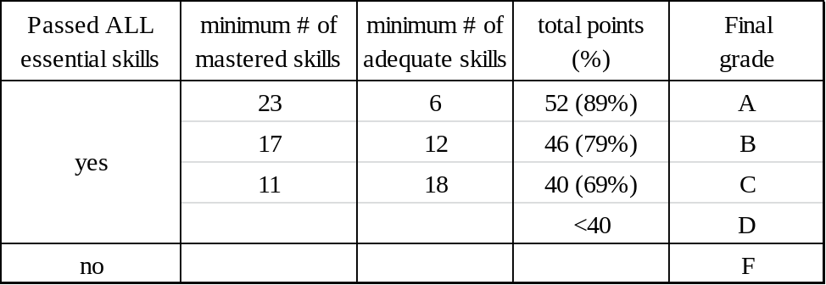
To help you understand this grading scheme, there are 2 tables below that lay out the different combinations of mastered and adequate skills you can obtain to arrive at a given grade. If you do some math, you will find that for an A, you really only need to master 79% of the objectives (26 of 33), but you will need to show some level of competence on the remaining 7 skills. Not surprisingly, there are even more combinations for a C—you can develop you own grade model in excel to figure out just how many.

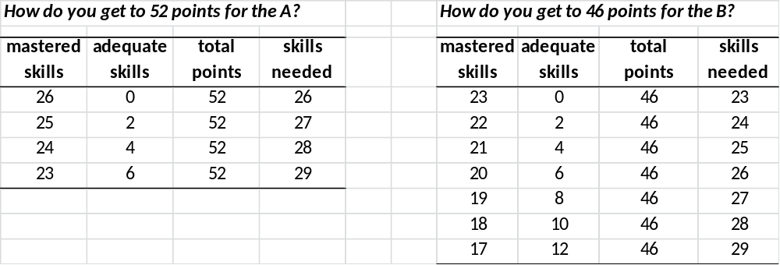

Math Support
Because many of our topics are heavy on the quantitative calculation, Jessica Johanningmeier, the Quantitative Reasoning Consultant, is available to help with math review, quantitative problem solving, data presentation, and other math-related issues. Jessica’s office is located in Cole Library, x4222.

Finding Enlightenment
You’ve probably heard the phrase “take responsibility for your learning”. The easy translation means to do the assignments and study for the exams. But people who learn well see this phrase as meaning they need to be curious about the subject matter, and pay more attention to what they don’t know. Then they put in the effort to identify exactly what they don’t know and figure it out by asking for help. While I strive to make the class interesting and understandable, I can neither make you learn nor make you interested in chemistry, only you can do that. Remember, everything can be interesting; you just have to make it so.
I hope at some point you will ask for some help. Figuring out the relationships among different concepts and executing the math can be tricky and requires practice. My best advice is to work diligently in short intensive sessions—don’t wait until the day before the exam and try to bash through it. For what it is worth, here is my simple two step plan for academic enlightenment.
- Think with your pencil. Outline the lectures and the book, work the problems, mark the parts you don’t understand, and then compose a question. And physically do this on paper, not just on the computer screen.
- Ask someone for help. Me, the tutors, friends who have had chemistry, anybody. Asking for help forces you to formulate a question, which makes you put the pieces together.

Academic Dishonesty
Part of the professional expectations for all scholars is to explicitly acknowledge the ideas, observations, or data created by others. Failing to do so is a form of academic dishonesty, and academic dishonesty is an extreme form of disrespect towards your peers and mentors. In its most general definition, academic dishonesty involves passing other people’s ideas or information as your own original work. Obvious examples include actions such as plagiarism (copying, paraphrasing, or stitching) or cheating on exams; however, your student handbook describes other examples of academic dishonesty (and how to avoid them).
Students misrepresenting their work in this course (i.e. plagiarizing or cheating) will automatically fail the assignment and depending on the circumstances may receive a failing grade. Violations of the College’s policies on academic dishonesty are also referred to the Registrar and the Dean of the College and will be dealt with as described in the student handbook.
A word about plagiarism… Collaboration is a great way to learn, and I strongly encourage you to work with others to help you understand the concepts. Nevertheless, I will expect you explain what you know in your own words. Copying verbatim, paraphrasing, or simply creating a cooperatively written document simply shows that you don’t take much pride in your work and makes it hard to convince others you are a valuable colleague to work with. Remember that this is not just about “getting through the class”; this is about you developing as an individual.

Other Course Policies
Meeting Times Count on being in class every day from 9-11 and 1-3. If I decide that we don’t need to meet for class on a specific day, you can be pleasantly surprised. If something about lab requires us to meet at 8:30 some morning, I will tell you the day before.
Office Hours If you need more focused help, I have an open door policy and am happy to stop what I am doing to answer your questions (unless I am helping another student). I am generally either in my office or wandering around this building. Find me and I am yours. Or contact me to schedule a specific time.
Due Dates Due to the short time frame of our block semesters, I do not accept late assignments. I will, however, arrange alternative deadlines for situations in which you have a college-sanctioned event (athletics, choir, band, etc.) that conflicts with the deadline or if you are facing some extenuating health circumstance. Any alternative deadline must be arranged prior to the original deadline, preferably at the time the assignment is given.
E-mail I will be using Moodle as a means to communicate with the class about assignments or changes to schedule and other matters of class management. You are responsible for checking your Cornell email account for these notices. Furthermore, if you decide to submit an assignment via email, your submission is not official until you receive a confirmation. Don’t assume that since you sent the email we received it.
Attendance I do not officially require attendance simply because showing up for a meeting is “professional” behavior, and at this point in your life, being a student is your profession. Although it is possible to never miss a class, there are times when certain extenuating circumstances (i.e. illness or family emergencies) prevent us from meeting our professional obligations. If you find yourself in this situation, it is your responsibility to notify me before the actual class meeting time that you will not be attending class.
In the event that you need a late withdrawal on the 15th day, your attendance is one of the things that I consider in deciding if you have made a “determined effort” to participate in the class. In the interest of defining “determined effort” with respect to attendance, it is unlikely that you would miss more than two classes during the block.
Withdrawals You may withdraw from any course on the 15th day of the block but only if 1) you have met the course attendance policy, 2) that you have completed all assignments, labs, and exams due on or before the 15th day, and 3) that you have, “in the instructor’s opinion, made a
Special Needs If you require academic adjustments because of a documented learning disability or health-related concern, it is your responsibility to ensure that you have 1) documented your needs with the Registrar, and 2) notified me within the first 3 days of the block. Accommodating students with special needs includes things such as help in taking notes, extra time for exams, or supervised tutorial support—it does not include opportunities for extra credit, different grading schemes, or alternative assignments. If you suspect you might have a learning disability but have not been diagnosed, you should consult with the Registrar or the Director of Counseling.

